TASK 7:
class Solution {
public int maxProfit(int[] prices) {
int minPrice = Integer.MAX_VALUE;
int maxProfit = 0;
for (int price : prices) {
minPrice = Math.min(minPrice, price);
maxProfit = Math.max(maxProfit, price - minPrice);
}
return maxProfit;
}
}

CASE 1:
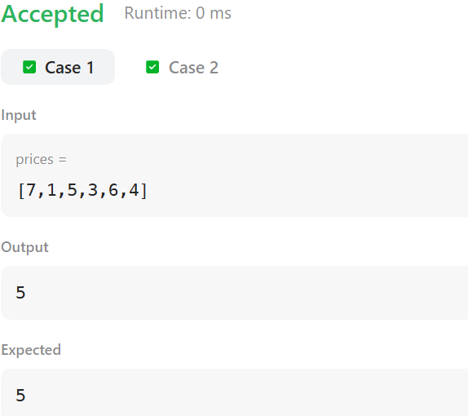

CASE 2:
